***SEMÁFORO (arduino IDE com vetor com pedestres e alerta)***

Foto do projeto:  
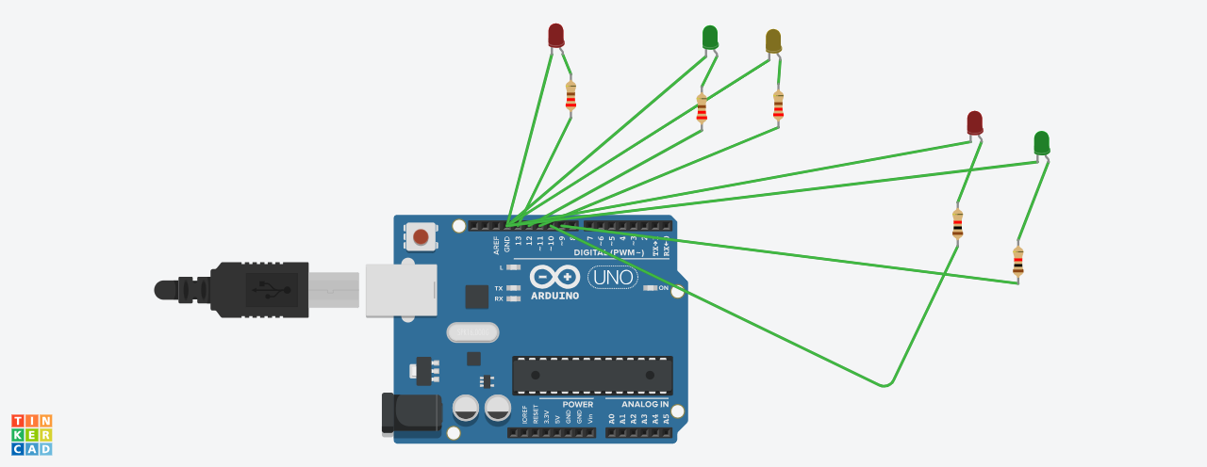

Programação:

int led[5];

void setup()

{

  led[0] = 13;

  led[1] = 12;

  led[2] = 11;

  led[3] = 10;

  led[4] = 9;

  pinMode(led[0], OUTPUT);

  pinMode(led[1], OUTPUT);

  pinMode(led[2], OUTPUT);

  pinMode(led[3], OUTPUT);

  pinMode(led[4], OUTPUT);

}

void loop()

{

  digitalWrite(led[0], HIGH);

  digitalWrite(led[1], LOW);

  digitalWrite(led[2], LOW);

  digitalWrite(led[3], LOW);

  digitalWrite(led[4], HIGH);

  delay(1000); // Wait for 1000 millisecond(s)

  digitalWrite(led[0], LOW);

  digitalWrite(led[1], LOW);

  digitalWrite(led[2], HIGH);

  digitalWrite(led[3], HIGH);

  digitalWrite(led[4], LOW);

  delay(1000); // Wait for 1000 millisecond(s)

  digitalWrite(led[0], LOW);

  digitalWrite(led[1], HIGH);

  digitalWrite(led[2], LOW);

  digitalWrite(led[3], HIGH);

  digitalWrite(led[4], LOW);

  delay(1000); // Wait for 1000 millisecond(s)

}